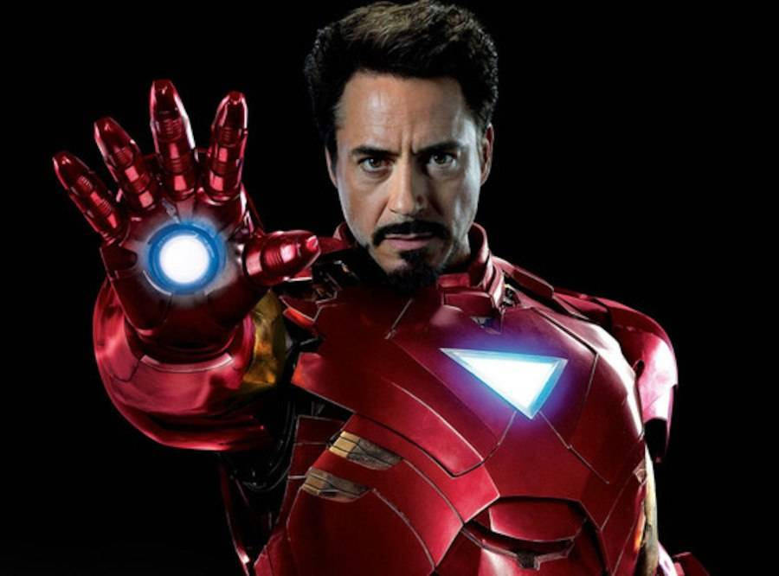

***Iron Man*** is a 2008 American [superhero film](https://en.wikipedia.org/wiki/Superhero_film) based on the [Marvel Comics](https://en.wikipedia.org/wiki/Marvel_Comics) character [of the same name](https://en.wikipedia.org/wiki/Iron_Man), produced by [Marvel Studios](https://en.wikipedia.org/wiki/Marvel_Studios) and distributed by [Paramount Pictures](https://en.wikipedia.org/wiki/Paramount_Pictures).[1](https://en.wikipedia.org/wiki/Iron_Man_(2008_film)#endnote_1) It is [the first film](https://en.wikipedia.org/wiki/List_of_Marvel_Cinematic_Universe_films) in the [Marvel Cinematic Universe](https://en.wikipedia.org/wiki/Marvel_Cinematic_Universe). The actor Robert Downey Jr is Tony Stark (Iron Man)

The History in the movie is about Tony Stark who is a Genius, billionaire, and playboy; who has inherited the defense contractor Stark Industries from his father,So he was in afghanistan with his friend James Rhodes to demonstrate the new Jericho missile but after he is captured and imprisioned in a cave by a terrorist group, but he met a friend called Yinsen who secretly and quietly build the suit for scape, but when Tony returns home he announces that his company will no longer manufacture weapons

So Tony in his home workshop,Stak builds a sleeker,more powerful versión of his improvised armor suit, So Tony only want destroy the terrorist group that was used his weapons but his friend Obadiah Stane betrays to Tony because only want be powerful, so Tony discover this and he fight with he.

So after Nick Fury find to Tony, and he explaining that he wants to discuss the Avenger Initiative